**Accounting and Financial Analytics with zoho books**

**Assignment – 4**

**Task 1 – Stock Market Analysis**

**Objective :** Analyzing the performance of APPLE Inc over the past year

**INTRODUCTION**

**APPLE Inc**



Apple Inc. (formerly Apple Computer, Inc.) is an American multinational corporation and technology company headquartered in Cupertino, California, in Silicon Valley. It designs, develops, and sells consumer electronics, computer software, and online services. Devices include the iPhone, iPad, Mac, Apple Watch, Vision Pro, and Apple TV; operating systems include iOS, iPadOS, and macOS; and software applications and services include iTunes, iCloud, Apple Music, and Apple TV.

For most of the period between 2011 and 2024, Apple was the world's largest company by market capitalization until it lost this position to Microsoft in January 2024.In 2022, Apple was the largest technology company by revenue, with US$394.3 billion. As of 2023, Apple was the fourth-largest personal computer vendor by unit sales, the largest manufacturing company by revenue, and the largest vendor of mobile phones in the world. It is one of the Big Five American information technology companies, alongside Alphabet (the parent company of Google), Amazon, Meta (the parent company of Facebook), and Microsoft.

**Key businesses**

1. **Hardware Products**: Apple designs, manufactures, and sells a range of hardware products including:
   * **iPhone**: Apple's flagship product, a line of smartphones.
   * **iPad**: A line of tablets.
   * **Mac**: A line of personal computers including MacBook, iMac, Mac Pro, and Mac mini.
   * **Apple Watch**: A line of smartwatches.
   * **Apple TV**: A digital media player and microconsole.
   * **AirPods**: Wireless earbuds.
   * **HomePod**: A smart speaker.
2. **Software Products**: Apple develops and distributes software and operating systems for its devices, including:
   * **iOS**: The operating system for iPhone, iPod Touch, and iPad.
   * **macOS**: The operating system for Mac computers.
   * **watchOS**: The operating system for Apple Watch.
   * **tvOS**: The operating system for Apple TV.
   * **iTunes**: A media player, media library, Internet radio broadcaster, and mobile device management application.
   * **iCloud**: A cloud storage and cloud computing service.
3. **Services**: Apple provides various services to its customers:
   * **App Store**: An online platform for purchasing and downloading software applications and mobile apps.
   * **Apple Music**: A subscription-based music streaming service.
   * **Apple TV+**: A subscription-based video streaming service.
   * **Apple Arcade**: A subscription-based gaming service.
   * **Apple Pay**: A mobile payment and digital wallet service.
   * **AppleCare**: Apple's warranty and support services.
   * **iMessage**: Apple's proprietary instant messaging service.
4. **Retail**: Apple operates retail stores worldwide, known as Apple Stores, which sell Apple hardware, software, and third-party accessories. These stores also provide technical support and services.
5. **Content and Media Production**: Apple is increasingly investing in original content and media production through services like Apple TV+.
6. **Wearables, Home, and Accessories**: This segment includes sales of Apple Watch, AirPods, HomePod, and other accessories.

Apple's revenue primarily comes from the sales of hardware products, but its services segment has been growing steadily and is increasingly significant in terms of revenue and profit. Keep in mind that business strategies and product offerings may evolve over time, so it's recommended to check the latest information for the most up-to-date details on Apple's key businesses.

**DATA ANALYSIS**

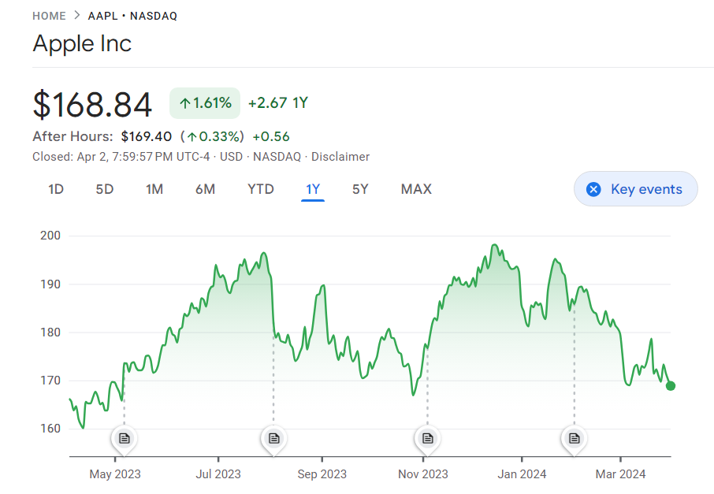

**Historical price data**

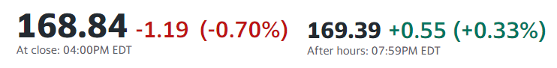

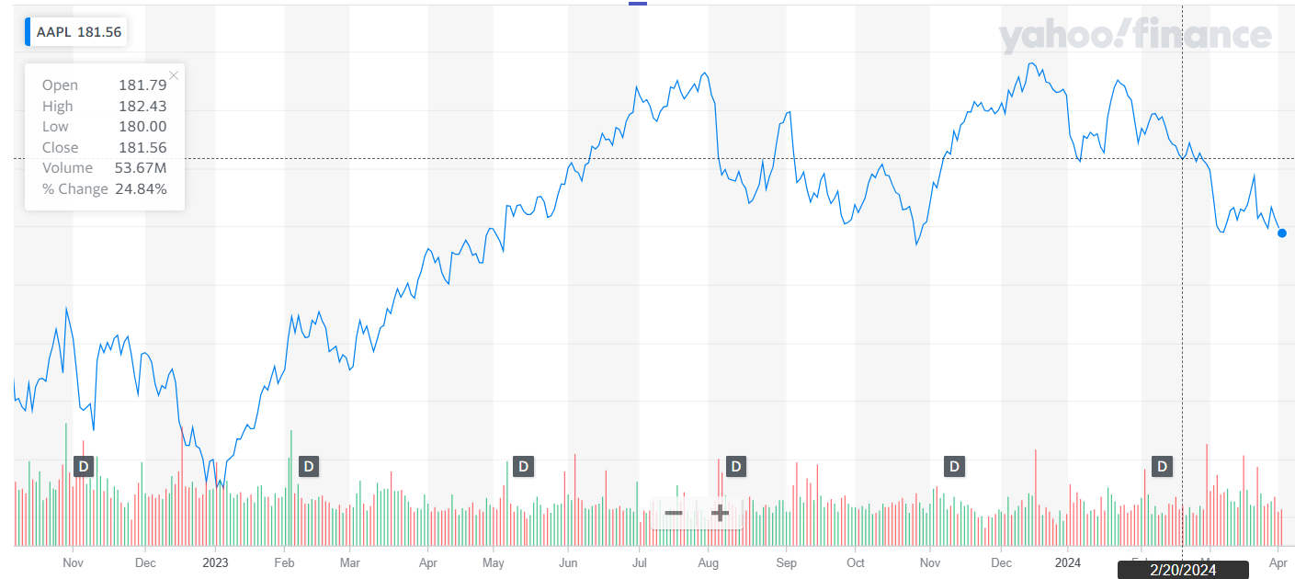

**historical stock price data chart**

**Key metrics**

Key metrics for assessing Apple Inc.'s performance typically include financial, operational, and market-related indicators. Here are some of the key metrics commonly used to evaluate Apple:

1. **Revenue**: Total income generated by Apple from its sales of products and services.
2. **Net Income**: The profit made by Apple after deducting all expenses from its revenue.
3. **Gross Margin**: Percentage of revenue remaining after deducting the cost of goods sold (COGS).
4. **Operating Margin**: Operating income expressed as a percentage of revenue, indicating the efficiency of Apple's operations.
5. **EPS (Earnings Per Share)**: Net income divided by the total number of outstanding shares, indicating the portion of profit allocated to each share of Apple's common stock.
6. **Cash and Cash Equivalents**: Amount of cash and assets easily convertible into cash held by Apple, reflecting its liquidity position.
7. **Debt Levels**: Total debt obligations of Apple, including long-term and short-term debt, compared to its equity and cash reserves.

**Historical annual stock price data**

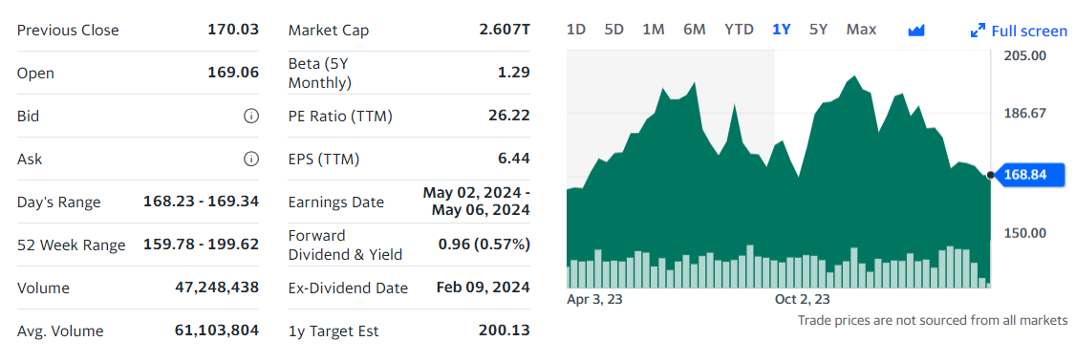

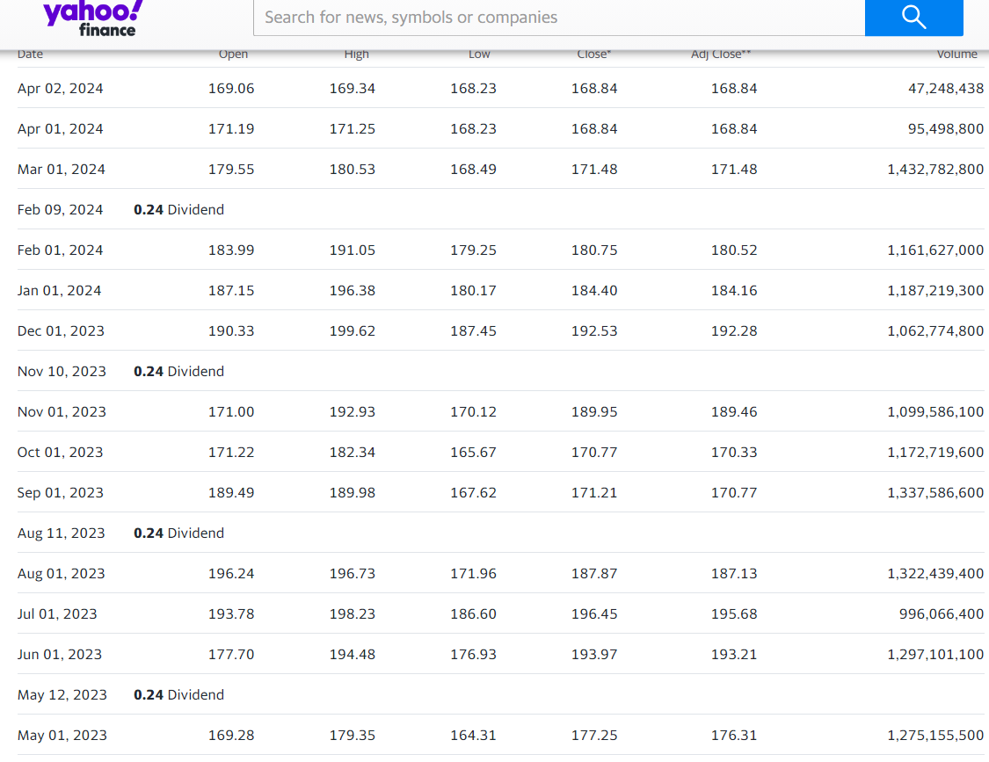

**Stock price change chart**

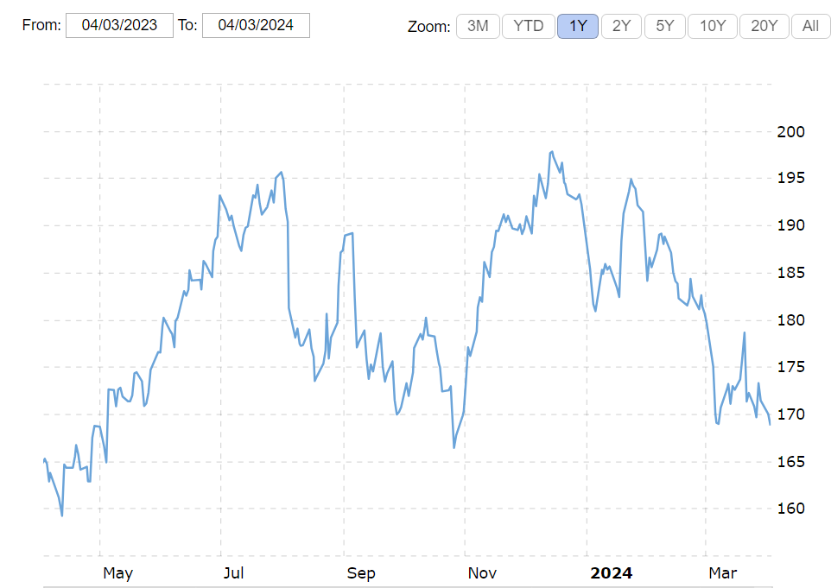

**Volatility**

The volatility here is measured as the annualized standard deviation between monthly returns from the security over the past year. In most cases, the higher the volatility, the riskier the security. As of today (2024-03-27), Apple's Volatility is **22.51%**

Apple Inc., like many other publicly traded companies, experiences fluctuations in its stock price, resulting in varying levels of volatility. Here are some factors contributing to the volatility of Apple's stock:

1. **Earnings Reports**: Apple's quarterly earnings reports often lead to significant movements in its stock price, depending on whether the company exceeds, meets, or falls short of analysts' expectations.
2. **Product Announcements and Innovation**: Apple's stock price can be influenced by product announcements, especially for flagship products like the iPhone, iPad, and Mac. New innovations or features that capture consumer interest can lead to stock price increases, while disappointing product launches may result in declines.

**Apple (NAS:AAPL) Beta**

**: 1.21 (As of Today)**

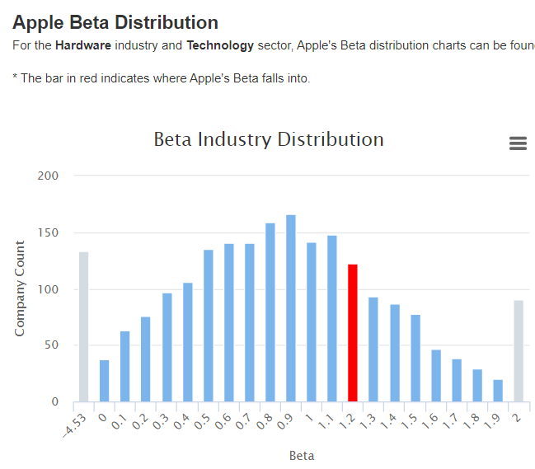

**Standard deviation**

The **standard deviation** of **Apple Inc. (AAPL)** stock price over the past year is approximately **9.82**. This measure indicates the **volatility** or oscillation of the stock’s price around its average value. Higher volatility implies greater price fluctuations during that period, while lower volatility suggests more predictability.

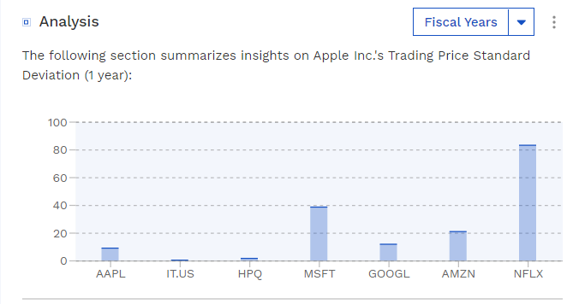

**Average trade volume**

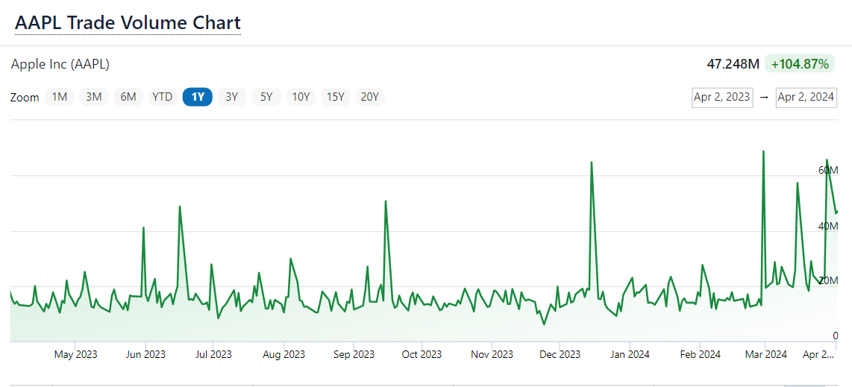

**Stock comparison and analysis**





vs

|  |  |  |  |  |  |  |  |  |  |  |  |
| --- | --- | --- | --- | --- | --- | --- | --- | --- | --- | --- | --- |
| Symbol | | AAPL | | NFTY | |  | |  | |  | |
| Company | | Apple Inc | | FT India Nifty 50 EW ETF | |  | |  | |  | |
| **Price Information** | |  | | | | | | | | | |
| Exchange | | NASDAQ | | NASDAQ | |  | |  | |  | |
| Open | | 169.08 | | 57.23 | |  | |  | |  | |
| High | | 169.34 | | 57.29 | |  | |  | |  | |
| Low | | 168.23 | | 56.89 | |  | |  | |  | |
| Last | | 168.84 | | 57.01 | |  | |  | |  | |
| Change | | -1.19 | | -0.19 | |  | |  | |  | |
| % Change | | -0.70% | | -0.33% | |  | |  | |  | |
| Volume | | 49,329,398 | | 62,900 | |  | |  | |  | |
| 20-Day Average Volume | | 68,682,375 | | 31,945 | |  | |  | |  | |
| Previous Close | | 170.03 | | 57.20 | |  | |  | |  | |
| Industry | | Computer - Mini | | N/A | |  | |  | |  | |
| Has Options | | Yes | | Yes | |  | |  | |  | |
| **Technicals** | |  | | | | | | | | | |
| 20-Day Moving Average | | 171.90 | | 56.63 | |  | |  | |  | |
| 20-Day Raw Stochastic | | 5.84% | | 57.39% | |  | |  | |  | |
| 20-Day Relative Strength | | 38.95% | | 55.68% | |  | |  | |  | |
| Weighted Alpha | | -3.36 | | +32.70 | |  | |  | |  | |
| Today's Opinion | | 88% Sell | | 88% Buy | |  | |  | |  | |
| Previous Opinion | | 88% Sell | | 88% Buy | |  | |  | |  | |
| Last Month's Opinion | | 24% Sell | | 100% Buy | |  | |  | |  | |
| **Performance** | |  | | | | | | | | | |
| **5-Days** | |  | | | | | | | | | |
| %Chg | | -1.18% since 03/25/24 | | +1.89% since 03/25/24 | |  | |  | |  | |
| Low | | 168.23 on 04/02/24 | | 55.92 on 03/27/24 | |  | |  | |  | |
| High | | 173.60 on 03/27/24 | | 57.46 on 04/01/24 | |  | |  | |  | |
| **1-Month** | |  | | | | | | | | | |
| %Chg | | -6.02% since 03/01/24 | | -0.58% since 03/01/24 | |  | |  | |  | |
| Low | | 168.23 on 04/02/24 | | 55.34 on 03/19/24 | |  | |  | |  | |
| High | | 178.67 on 03/20/24 | | 58.25 on 03/08/24 | |  | |  | |  | |
| **3-Month** | |  | | | | | | | | | |
| %Chg | | -9.05% since 01/02/24 | | +4.97% since 01/02/24 | |  | |  | |  | |
| Low | | 168.23 on 04/02/24 | | 53.37 on 01/23/24 | |  | |  | |  | |
| High | | 196.38 on 01/24/24 | | 58.25 on 03/08/24 | |  | |  | |  | |
| **6-Month** | |  | | | | | | | | | |
| %Chg | | -2.83% since 10/02/23 | | +17.89% since 10/02/23 | |  | |  | |  | |
| Low | | 165.67 on 10/26/23 | | 46.60 on 10/26/23 | |  | |  | |  | |
| High | | 199.62 on 12/14/23 | | 58.25 on 03/08/24 | |  | |  | |  | |
| **Key Statistics** | |  | | | | | | | | | |
| Market Capitalization, $K | | 2,625,583,040 | | 190,984 | |  | |  | |  | |
| Shares Outstanding, K | | 15,441,881 | | 3,350 | |  | |  | |  | |
| Annual Sales | | 383,285,000,000 | | 0 | |  | |  | |  | |
| Annual Net Income | | 96,995,000,000 | | 0 | |  | |  | |  | |
| Last Quarter Sales | | 119,575,000,000 | | N/A | |  | |  | |  | |
| Last Quarter Net Income | | 33,916,000,000 | | N/A | |  | |  | |  | |
| 60-Month Beta | | 1.27 | | 0.72 | |  | |  | |  | |
| **Per-Share Information** | |  | | | | | | | | | |
| Most Recent Earnings | | 2.18 on 02/01/24 | | N/A | |  | |  | |  | |
| Latest Earnings Date | | 05/02/24 | | N/A | |  | |  | |  | |
| Most Recent Dividend | | 0.240 on 02/09/24 | | 0.079 on 03/21/24 | |  | |  | |  | |
| Next Ex-Dividends Date | | 02/09/24 | | 03/21/24 | |  | |  | |  | |
| **Ratios** | |  | | | | | | | | | |
| Price/Earnings ttm | | 26.71 | | 17.01 | |  | |  | |  | |

**Key events of APPLE Inc**

Certainly, here are some key events in Apple's history along with their effects on the company's present performance:

1. Launch of the iPhone (2007): The introduction of the iPhone revolutionized the mobile phone industry, setting new standards for smartphones. Its immense success propelled Apple to new heights, establishing it as a dominant player in the tech industry and significantly contributing to its present performance. Today, the iPhone remains one of Apple's primary revenue drivers.

2. Introduction of the iPad (2010): The iPad's launch created a new product category of tablets, further expanding Apple's product lineup. Although iPad sales have fluctuated over the years, it continues to contribute significantly to Apple's revenue and diversifies its product portfolio.

3. Passing of Steve Jobs (2011): The death of Apple's co-founder and visionary leader, Steve Jobs, in 2011 had a profound impact on the company. While Tim Cook took over as CEO and successfully led Apple, some analysts argue that the company has not introduced revolutionary products on the same scale as during Jobs' tenure.

4. Introduction of Services (2016-present): Apple has increasingly focused on its services business, including Apple Music, iCloud, Apple TV+, and Apple Arcade. This shift towards services has helped diversify Apple's revenue streams and reduce its reliance on iPhone sales.

5. Legal Battles and Regulatory Scrutiny (ongoing): Apple has faced various legal challenges and regulatory scrutiny worldwide, particularly regarding antitrust concerns related to the App Store and its business practices. These ongoing battles may affect Apple's future strategies and performance, depending on regulatory outcomes.

6. COVID-19 Pandemic (2020): The COVID-19 pandemic impacted Apple's operations, supply chain, and retail stores worldwide. However, Apple adapted by focusing on online sales and services, which mitigated some of the negative effects. The pandemic also accelerated certain trends, such as remote work and digital consumption, which benefited Apple's products and services.

7. Investments in Research and Development (ongoing): Apple continues to invest heavily in research and development, driving innovation across its product lines. This commitment to R&D has enabled Apple to maintain its competitive edge and introduce new technologies and features in its products, contributing to its present performance.

***

**N. Anil Kumar**

**Andhra University**